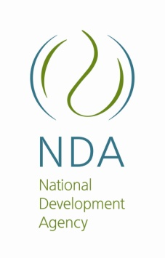

NATIONAL OFFICE

Physical Address
26 Wellington Road
Parktown
2193

NDA Provincial Offices

GAUTENG Provincial Office
No. 108 Fox Street
Metropolitan Building, 2nd floor
Johannesburg
2001

LIMPOPO (NORTHERN PROVINCE
Femnic Building
66A Market Street
Polokwane
0700

EASTERN CAPE
Vincedon Office Park
08 Donald Road
Vincent
East London
5201

FREE STATE

Ilustae Building,

3rd floor,

Cnr St Andrews and Aliwal Street,

Bloemfontein,
9300

KWAZULU NATAL
9 Dorothy Nyembe Street
9th floor Corporate Place Building
DURBAN
4001

NORTH WEST
IDT Building
First Floor
ERF4059 Newton Street
Mafikeng
2749

NORTHERN CAPE
13 Dalham Road
Kimberley
8301

MPUMALANGA
Ground floor
16 Branders Street
Nelspruit
1200

WESTERN CAPE
The Chambers Building
2nd Floor
50 Keerom Street
Cape Town
8001

District Offices

Eden District (Western Cape)
Office No.22,
63 York Street
George

Chris Hani District Eastern Cape
Old ECDC Building
22 Cathcart Road
Queenstown

West Rand District Gauteng

5 Pollock Street,
Randfontein

Greater Sekhukhune District Limpopo
26 Jane Furse, Sekhukhune District
New Hospital
DSD Offices

King Cetshwayo District KwaZulu-Natal

Umhlathuze Municipality
Corner Pearce Crescent and Turn Bull Road
Empangeni near Empangeni Museum
Temporary extension: 5597

Ehlanzeni District Mpumalanga
1246 Amerd Street
Simunye Shopping Centre
Office number 7
Hazyview

