

TERMS OF REFERENCE

FOR

THE APPOINTMENT OF A SERVICE PROVIDER FOR THE DEVELOPMENT OF A MASTER CSOs DATABASE AND AN INTEGRATED INFORMATION MANAGEMENT SYSTEM
CLOSING DATE: 23 July 2018
CLOSING TIME: 11:00
BID REF: NDA30/IT 01/18

SUBMISSION OF PROPOSALS

All bid documents must be delivered at the NDA Head Office on or before the closing date and time. The Head Office address is: 26 Wellington Road, Parktown, Johannesburg, 2193

Service providers can send bid documents using door to door courier services but NO documents can be sent to the NDA postal address or provincial NDA offices.

Submissions must be strictly submitted inside the tender box which is at the main entrance and accessible 24/7.

The supplier's envelope/s MUST clearly have the description of the Bid " The Development of a master CSOs database and an integrated information management system

A TWO-ENVELOPE system will be used for the submission of quotations

Commercial Envelope
This envelope must contain price quotations plus all the mandatory documents as listed in section 8.3 of this document.
Technical Envelope
This envelope must contain all information listed in section 8 of this document.
Contact person: Ms Nomakhaya Nelani 011 018-5607 / 0810756904 between 08h30 to 17h00 on weekdays. Queries can also be sent in writing to nomakhayan@nda.org.za (on the website go to Procurement, click tenders then you will have a view of all available tenders. For minutes of briefing sessions; go to Procurement, click tenders, click Questions & clarifications)

COMPULSORY

BRIEFING SESSIONS HAVE BEEN SCHEDULED AS FOLLOWS:

Date | Time | Venue
06 July 2018 | 10:00 | NDA Main Boardroom  26 Wellington Road, Parktown  Johannesburg, 2193

Failure to attend the Compulsory briefing session will result to the disqualification of the bid
OVERVIEW OF NDA

The National development Agency is a public entity listed under Schedule 3A of the Public Finance Management Act (PFMA). It was established in terms of the National Development Agency Act No 108 of 1998 as amended.

  - Our mandate

In terms of the National Development Agency (NDA) Act (Act No 108 of 1998 as amended), NDA was mandated to contribute towards the eradication of poverty and its causes by granting funds to Civil Society Organisations (CSOs) to:

- Implement development projects in poor communities, and
- Strengthen the institutional capacity of other CSOs that provide services to poor communities.

  - Our mission

Facilitate sustainable development by strengthening Civil Society Organisations involved in poverty eradication through enhanced grant funding and research.

  - Our vision
A society free from poverty.

  - Our values

Integrity
Dignity
Empowerment
Accountability & Responsibility
Transparency
Excellence
Partnering

- BACKGROUND

  - Introduction

The NDA has restructured its business model and formulated a strategy with the purpose of giving effect to the new model. The NDA effectively becomes the agent that will work through, and capacitate Civil Society Organizations (CSOs) to deliver social programmes and projects to the poorest communities in South Africa and drive its Vision of a “Society free of Poverty”. The NDA also wants to position itself as the only Social Sector Agency that capacitates and work through CSOs. This would mean that all government Ministries, Departments and Agencies would need to see the NDA as its Agency of choice when wanting to engage or work with CSOs.

The NDA strategy also ensures that its projects and programmes are guided by National Development Plan 2030 (NDP), Outcome 13 of the National Development Plan with the goal to contribute directly to:
- Sub-Outcome 2 - Improved provision (improved quality and access) of Early Childhood Development Services for children aged 0-4.
- Sub-Outcome 3 - Strengthened community development interventions.
- Sub-outcome 5: Optimal systems to strengthen coordination, integration, planning, monitoring and evaluation of social protection services.

The NDA has gone through a process to developing and approving the Master Systems plan, in order to align ICT strategies to the business strategy. The Systems Architecture proposed therefore not only addresses the enablement of the business model but also finds solutions to the significant challenges currently experienced by the business due to the lack of integrated information management systems.

The development and implementation of an integrated CSOs Information Management System will enable the NDA to effectively and efficiently achieve its mandate as per the NDA Act (Act No 108 of 1998 as amended), strategic goals and objective. The implementation of the required system is expected to achieve the following business objectives: -
- Provide the NDA with an integrated solution that promotes interoperability and a single view of the CSOs information;
- Reduce the number of small applications/ Excel sheets/ tools that are operating in silos.
- Improved Service Delivery to all business areas.

  - The NDA Overview Business Model

The NDA has adopted a CSO development model as its operational framework for delivering on the outcomes NDP 2030. The strategy of the NDA is to empower CSOs and to work through these CSOs to achieve its mandate of empowering poor communities and alleviating poverty. The NDA’s strategy thus puts the CSOs at the core of its operational model. This means that the NDA must leverage on technology to integrate and to automate the processes and use information in an integrated architecture to make informed decisions, become more efficient, make information available irrespective of location and time and, to apply resources strategically. The figure below illustrates the connection between the poor communities, CSOs and the NDA: -

The NDA will therefore position itself as the primary agent that strengthens the capacity of the CSOs to deliver quality products and services to poor communities and households. This strategy also requires process integration with CSOs to ensure that the NDA can provide necessary support and monitor projects and programmes. This is particularly relevant for Level 1 and Level 2 CSOs as described in the diagram below.
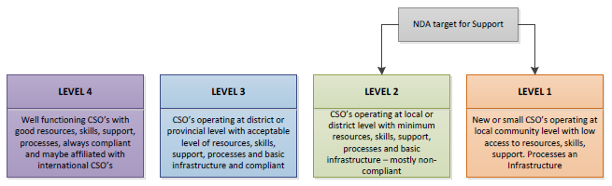
NDA Classification levels of CSOs

De-Centralized Operating Model

The NDA’s newly restructured operations strategy is one of de-centralization where the operations are being pushed down to the level of Provincial and District Office level. The implementation of projects and programmes will therefore happen at the provincial level with administration, oversight, research, monitoring, Grant allocation and policy formulation taking place at the National level. The strategy will therefore require integrated systems for the National Office to deliver on their mandate of Administration and Oversight.

The de-centralized model recognizes that it is the Provincial and District offices that is in tune with the needs of their respective communities as they are embedded within these communities with a better understanding of needs, cultural and diversity dynamics. This means that the Provincial and District Offices must be adequately enabled and supported for them to meet their Key Performance Indicators. They will need access to systems with an elevated level of performance and connectivity to back-end applications which will reside at the Head Office Data Centre.

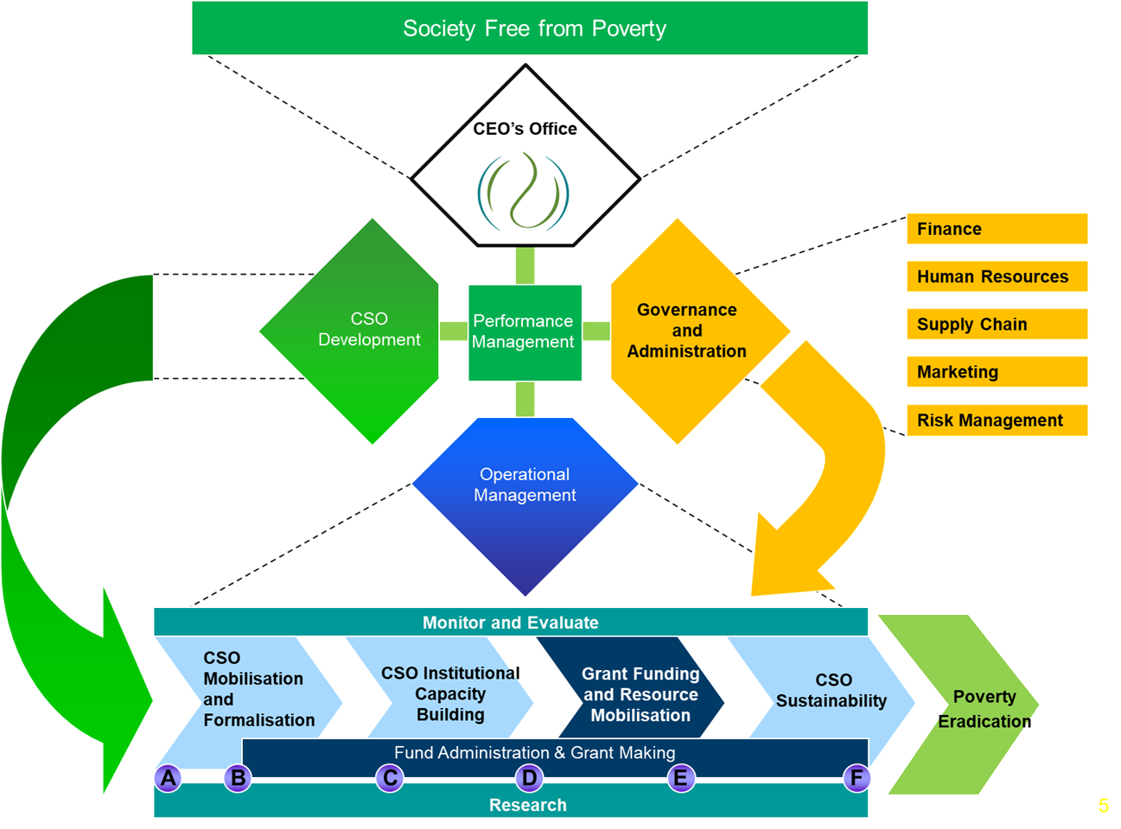

  - Business Architecture

The figure below illustrates the lines of business reside on an architectural foundation supported by technology solutions that enables their processes, thus improving efficiencies. The ICT Strategy seeks to achieve this enablement of the business model.

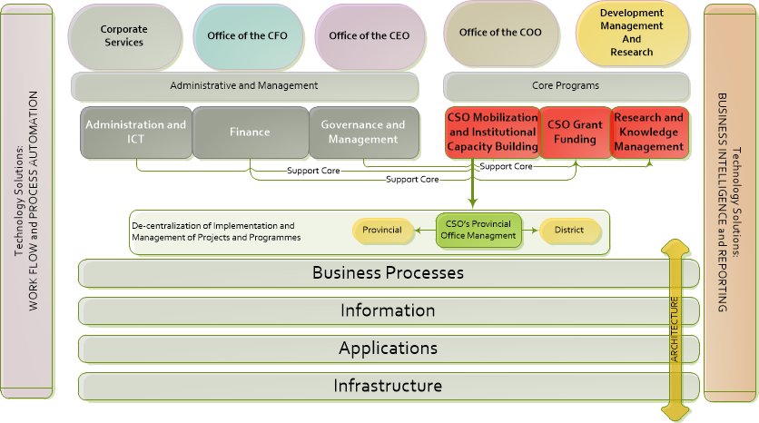

    - Business Programmes
Programme 1: Governance and Administration

This programme is aimed at promoting and maintaining organisational excellence and sustainability through effective and efficient administration.

Programme 2: CSOS Development:

The programme provides a comprehensive package that aims at developing CSOs to their full potential so as to ensure that CSOs, especially those operating in poor communities, have capabilities to provide quality services to the communities they are serving.

Programme 3: Research

This programme is the key pillar of the NDA, to fulfil the secondary mandate as prescribed by the NDA Act, “to promote- a) consultation, dialogue and sharing of development experience between civil society organisations and relevant organs of state; and debate on development policy; and (b) to undertake research and publication aimed at providing the basis for development policy”.

  - Problem Statement

The NDA currently has no ICT systems in place to enable the strategy and core business functions (Sub programmes 1 to 4). The inefficiencies within the Provincial and District Offices are largely perpetuated by the lack of systems, and the manual mechanisms are cumbersome and time-consuming. Provincial Office have piles of documents, due to the lack of an electronic document and information management system. The current gaps within the ICT systems are not limited to the follows:
- No System to monitor grand funding projects and programmes. Performance evaluations (real-time visibility) is done on spreadsheets;
- No formal Master CSOs Database, as per the requirement of the NDA Act;
- No funders Database and no integration to external donor and funding databases;
- No integration with stakeholders – DSD, CSOs, Funders or any other stakeholders;
- No real-time reporting or Business Intelligence system, most of the tools are on the excel spread sheets
- No access to systems on the ground; e.g. if they do a seminar or workshop as part of the CSO Mobilization Process for CSOs, they cannot directly access a system and record information such as Capture CSO details into a database;

The figure below highlights some of the gaps within the information systems environment that clearly illustrates the difficulty the business has due to a lack of systems.

  - Current NDA Applications

The NDA currently has a number of systems and applications used in the organisation; below is a list of current systems:

Business Application Audit - NDA
Application Name | Description | Type | Operating System | Database | Platform | Support | Used By
SAGE VIP | HR  Payroll  ESS | Web/Mobile | Windows 2010 | SQL | .NET | Outsourced VIP | HRM
Microsoft Dynamics GP | Financial System | Client/Server | Windows Server 2015 R2 | SQL Server | .NET | Outsourced | Finance and SCM
Requisition Site | Requisitions | Web-base | Windows Server 2012 R2 | SQL Server | EF | Outsourced | NDA
BP | Business Portal | Business Portal - Travel Reservations | Windows Server 2003 | SQL Server | .NET | In-house | NDA
HEAT | Service Desk | ICT Services Management | Windows Server 2008 R2 | SQL Server | .NET | Outsourced | NDA
SharePoint | CSOs Development tool (Assessments and Needs Analysis) | Web-base | 2016 | SQL Server | SharePoint | In-house | COO

Summary of Applications:
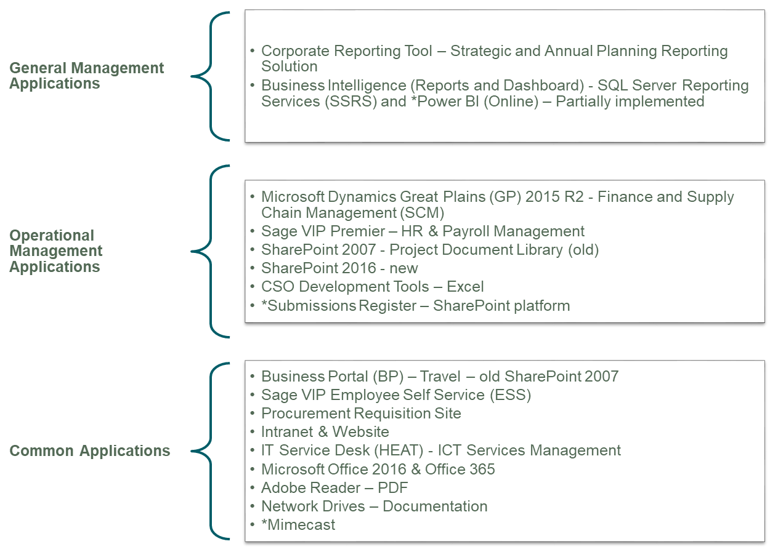

- PURPOSE OF THE BID

The purpose of the request for bids is to appoint suitable services providers for the development of a Master CSOs Database and the integrated CSOs Information Management System.

  - System Objectives

The following system objectives have to be achieved with the implementation of the required solution:
- Address the technology shortcomings stipulated in the problem statement.
- Ensure that reports are drawn from a single source (Single Truth).
- Employ the latest technology where applicable.
- Propose a system that is scalable to accommodate future growth of the organisation’s.
- Define a system that is adaptable to accommodate user requirement changes and future enhancements.
- Provide a system that is logical and user friendly.
- Ensure data integrity and data security by implementing quality control procedures at data entry levels.

  - Key System Development Principles
The ICT Strategy is sensitive to the current fiscal constraints under which the NDA operates. It is for this reason that a pragmatic approach has been taken to the proposed application solutions which seeks to propose systems which are sensible and realistic in a way that is based on practical rather than theoretical (or nice to have) considerations. Some key principles which should apply during the development are:
- Fit for Purpose – Solutions will be implemented that delivers on its intended purpose and meets the goals and objectives of the organization.
- Keep things simple – Will avoid complexity and seek to implement processes, technology and solutions that are easy to maintain, skills are readily available, not over specked with unnecessary functionality and User Friendly.
- Don’t re-invent the wheel – Use what is currently working and leverage existing technology that meet the business requirements before looking at modern technologies and systems.
- Automate – Work smart and automate processes and business functions wherever possible.
- Leverage existing technology – Cost considerations are a priority, existing technologies within the NDA will first be considered first.

  - Enterprise Systems Architecture Tiers

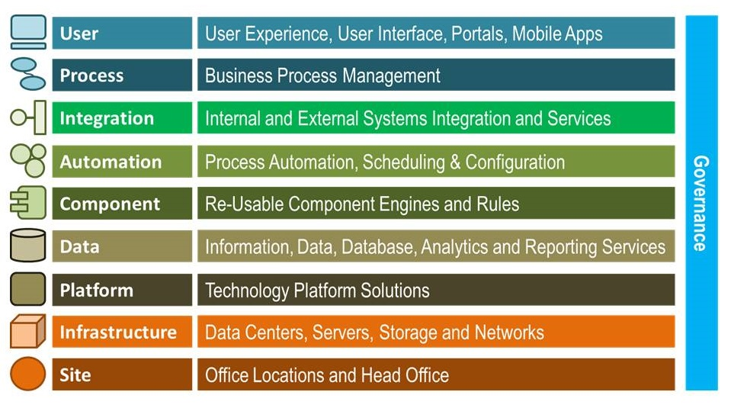

Considering the above, the NDA deemed it necessary to invite service providers to develop a Master CSOs Database and an integrated Information Management System, to be implemented within 10 months. In issuing this RFP, NDA seeks to identify a bidder who is able to provide the services required by the NDA in the manner set out in the Specifications (Terms of Reference) and will continuously seek improvements in cost competitiveness, value, efficiency, productivity and service level quality in the provision of the services for the mutual benefit of the NDA and the Bidder.

- SCOPE OF WORK

The development CSOs Master Database and Integrated Information Management System project should replace the current systems and excel tools with an integrated system. The overall goal of the project is to implement a system that improves services to the CSOs and Stakeholder by providing access to timely and accurate information for decision-making, and further assist the NDA to be more technologically competitive and efficient. The overall description is stipulated as follows:

  - Part one: Development of the CSOs Master Database
According to the NDA Act:
(1) The NDA must-
(a) act as a key conduit for funding from the Government of the Republic, foreign governments and other national and international donors for development work to be carried out by CSOs;
(c) contribute towards building the capacity of CSOs to enable them to carry out development work effectively; and
(d) create and maintain a database on CSOs, including, but not limited to, the scope and subject matter of their work and their geographical distribution, and share the information in that database with relevant organs of state and other stakeholders.

Therefore, the Act compels the NDA to create a database of CSOs that can be used to solicit funding and ensures that the database is accessible and available to all stakeholders. This is a crucial function that supports both the conduit for funding and the capacity-building interventions. The priority is therefore to firstly create a consolidated CSO Master Database and to build the application layer that will enable the relevant business functionality.

The service provider is expected to build a consolidated CSO Master Database. The data for this database will be migrated from different data sources, ranging from the Business Portal, Standalone CSO database at Head Office, the electronic CSO Databases at the Provincial and District Offices the paper based information within the various offices. Data collection scope will cover the data sharing from the master Non Profitable Organisation (NPOs) at Department of Social Development (DSD) and other Department Stakeholders who might be collecting the CSOs data. This Master database will integrate with the Data Warehouse and Portal at a later stage (Not within the current scope).

For the reengineering of the CSOs Master Database, the service provider is expected but not limited to:
- Review the CSOs database and reengineer the current design where necessary:
    - Identifying and consolidation of all NDA beneficiary data into a standard data record structure
    - Development of database for all beneficiary information
    - Migrating data records into SQL database
    - Migrating beneficiary data into Programme Data Management database
- Present the CSOs database User Interface (UI) on smart forms for maintenance purposes.
- Perform data cleaning and migrate from existing CSOs data where required.
- The CSO database should be maintainable through the following operations: create, read, update, delete (CRUD), the purpose of these operations is to allow the users to interact with the CSOs database in a user-friendly manner.
- Integrate the CSO Master database into an Integrated CSOs Information Management System.
- Provide technical designs of the reengineered CSO Master database.
- The CSO Master database must also be available for public consumption.

Current CSO Database Structure

  - Part Two: Development of an Integrated CSOs Information Management System

The development of the CSOs Integrated Information Management system is essentially automating the core businesses processes. The NDA has developed a set of CSOs tools on Excel spread sheets in order assess levels of maturity amongst other assessment and performance tracking. These tools are key information artefacts in the implementation of the information architecture and contain all the Data Types and Data Elements necessary to build the CSOs Information Management System. The NDA has done the detail mapping and articulating of the CSO processes and functions. Much of this work is contained in the “NDA Civil Society Organisation Development Framework, Guidelines And Tools…” document and essentially completes the first phase of business analysis.

    - Module 1 – CSO Mobilisation and Formalisation

The sub programme focuses on CSO engagements, assessments and needs analysis, prioritisations of interventions required by CSOs, facilitating registration of CSOs that need support to register with appropriate registration authorities (e.g. NPO and Cooperatives).

    - Module 2 – CSO Institutional Capacity Building

The sub programme will focus on strengthening institutional capacities of CSOs across all districts and local municipalities in nine provinces. The sub programme will focus on organisational development for the CSOs to ensure that these organisations have sound systems, processes and capabilities to deliver quality services, comply with good governance, accountability and reporting requirements of CSOs. The capacity building interventions will be provided through training, mentoring and incubation to all CSOs assessed and requiring institutional capacity-building development.

    - Module 3 – CSO Grand Funding and Resource Mobilisation
The sub programme focuses on providing grants to CSOs that work with poor communities, for purposes of developing their capacities to deliver quality projects and programmes. The resource mobilisation component of this sub programme aims at mobilising resource from the South African Government, foreign governments, international agencies, and the private sector to increase the funding base of CSOs working in poor communities.

The NDA Act allows the NDA to provide grants to CSOs through a conduit for government, foreign government (bilateral and multilaterals), private sector (corporate), international organisations and philanthropist (local and international). Second, the NDA can grant funds to CSOs from its allocation from National Treasury. These are the avenues that the NDA can fund CSOs from all its resources inflows.

The NDA grant funding approach to CSOs is aimed at developing the organisations to ensure they have capacities to deliver quality services, attract more funding based on their performance records. Sustain the organisations that can assist the organisation to expand and reach more people in poor communities where they operate. The framework they provide developmental processes on how the NDA will fund CSOs and the developmental milestones that need to be monitored to produce developmental outcomes of these organisations. The below figure illustrate the grand funding process, supported by the grand funding policy.

    - Module 4 – CSO Linkages and Sustainability

This sub programme focuses on ensuring that CSOs are linked to appropriate available opportunities and resources to sustain themselves and reduce dependency on donor funding, but creates their own demand for services and products that can be utilised by the public and government. This sub-programme will also ensure that CSOs are linked, or will create networks so that they can support each other on their development goals, in order to achieve sustainability.

The processes below summarises the programme 2 value chain:
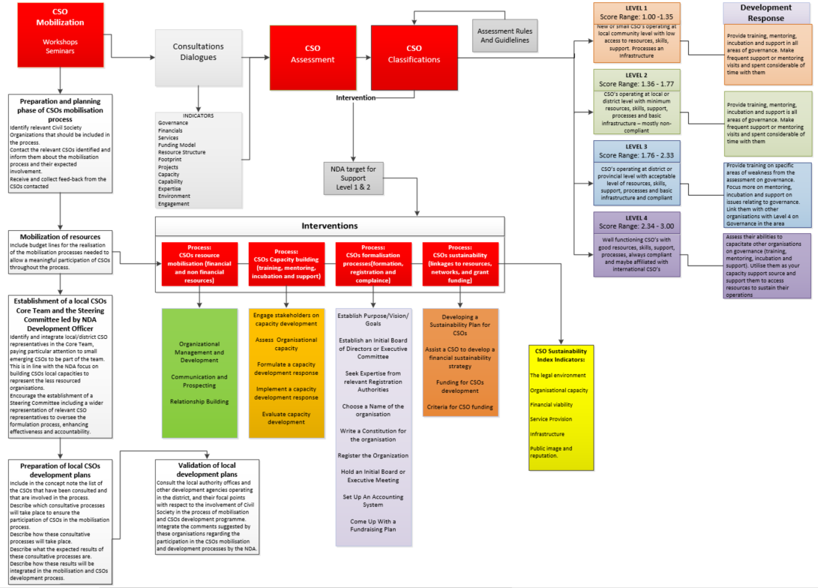

  - General Requirements

    - General Specifications for the development of CSOs Information Management System
The professional service provider is expected to develop a web-based solution, which has the minimum requirements but not limited to:
- Gather detailed business and functional requirements specifications for the development for the Solution
- Design and develop the Solution by considering the NDA current technologies i.e. SharePoint 2016, SQL Server 2016, Visual Studio 2015 and Power BI
- Migration of existing Corporate Reporting Solution data where required.
- User management capabilities e.g. permission and accessibility.
- Branding to be applied based on NDA standards.
- Document attachment capabilities.
- Risk assessment capabilities.
- Integration with financial system for reading budget values within programmes
- Provide technical and business documentations for the Solution

    - Minimum Security Controls Requirements

- Access must be granted based on personnel roles and the security principles of clearance, need to know, segregation of duties, and least privilege.
- Access to the system and its data should be controlled via authentication and authorisation. An authenticated person / user shall be granted access to only those information system resources necessary to perform their authorised task(s).
- The required system should provide a means by which individual users can be individually accountable for their actions.
- The system should protect applications and data according to its sensitivity and criticality against unauthorised access and protect hardware, software and data from accidental or deliberate unauthorised changes, destruction, disposal, removal and / or disclosure.
- The access permissions for system data should only be changed by the system’s administrator.
- System authentication must be integrated with Active Directory.
- System should be compliant to the relevant legislations e.g. POPI Act.
- The system must have the capability to ensure that data is not modified, altered, or deleted without authorization in either storage or in transit.
- Any unauthorized modification of data must yield an auditable security-related event.
- The system must log any attempt by the administrator to authorize any user to bypass the administrator-configured data integrity controls.
- The system must protect data integrity by performing data integrity checks.
- When data integrity checks fail, the system must reject the data.

    - Maintainability and Support

- The system should be designed in a maintainable manner. It will be easy to incorporate new requirements in the individual modules.
- The maintenance and support costs should be included on the proposal for the duration of 24 Months.
- The system should be hosted in house.

    - Usability

- Usability requirements for the system should include the following:
- User friendly and Well-formed graphical user interfaces
- Well-structured user menus and easy to navigate
- Informative error messages
- Help facilities, knowledge management portal and user manuals

    - Communications Interfaces
- The system should have a capability to send Short Message System (SMS) and emails services for notifications.
- Should be accessible to mobile devised.

    - Performance Requirements

- The response time when transecting must be faster throughout the day.
- The required system should be able to handle a multiple of concurrent users working on the system without affecting the system’s throughput.
- The system should be able to handle requests from different categories of users.

    - Reporting and Business Intelligent (BI)

- The software should generate following viewable and printable reports as per the NDA requirements.
- The system should allow some different method for navigating the data (access data) which are by location within our group company also by Site, Provinces and districts.
- Systems enable NDA to run customized report as needed.
- To supplement the records created in the system, the system should make it possible to link to or upload other electronic files in their native format (e.g. images)
- Provide reporting features to import and export the data with ‘MS Excel’ / ‘PDF’.
- Import data from other source (Text File) in order to speed up the migration process for the system (such as upload material master data, CSOs data, etc.)

    - Integration Requirements

The provider should provide the integration test among modules with focusing to the following purpose:
- To provide overview of end to end process for each module
- To know and understand the impact to others if any step is not done properly
- To confirm that system running properly as expected
- To confirm the reports generated in these processes meet our expectation
- Data migration from current to the new platform
- Must be Operating System (OS) and browser independent.

- PROPOSED PROJECT DURATION

The proposed service should be implemented within 10 months.

- COMMERCIAL EVALUATION

Bids will be evaluated in accordance with the Preferential Procurement Regulations, 2017, using the 80/20 preference points system as prescribed in the Preferential Procurement Policy Framework Act (PPPFA, Act 5 of 2000). The lowest acceptable bid will score 80 points for price and maximum of 20 points will be awarded for attaining the Broad-Based Black Economic Empowerment (B-BBEE) status level of contribution.

The bid proposals received will be evaluated in two (2) phases. On the first phase bids will be evaluated on functionality and on the second phase in accordance with the 80/20 preference points system respectively.

Bid proposal must score a minimum of eighty (80) points or more out of hundred (100) points on functionality in order to qualify for advancement to the next phase of evaluation. Second phase, a bid proposal scoring less than 80 out of 100 will not be considered for further evaluation and will be disqualified.

Phase two: During this phase, bid proposals that passed the first phase will be further evaluated based on the 80/20 preference points system in accordance with the PPPFA Act, where 80 points will be attained in respect of price (the lowest acceptable bid will score 80 points and bidders that quoted higher prices will score lower points for price on a pro-rata basis) and 20 points will be awarded for attaining the Broad-Based Economic Empowerment (B-BBEE) status level of contribution in accordance with the table below:

B-BBEE Status Level of Contributor | Number of points (80/20 system)
1 | 20
2 | 18
3 | 14
4 | 12
5 | 8
6 | 6
7 | 4
8 | 2
Non-compliant contributor | 0

In order to claim the B-BBEE Status Level of Contributor, bidders must submit Sworn Affidavits or original and valid B-BBEE Status Level Verification Certificates or certified copies thereof, issued by accredited Verification Agencies such as SANAS or Registered Auditor approved by the IRBA together with their bids, to substantiate their B-BBEE claims. Exempted Micro Enterprises must submit a letter from the Accounting Officer who is appointed in terms of the Close Corporation Act.

Bidders who do not submit B-BBEE Status Level Verification Certificate or are non-compliant contributors to B-BBEE do not qualify for preference points for B-BBEE, but will not be disqualified from the bidding process. They will score points out of 80 for price only and zero (0) points out of 20 for B-BBEE.

Bidders are requested to complete the preference claim form (SBD 6.1 and 6.2) in order to claim preference points.

The highest ranked bidder will be awarded the bid. It should be noted also that the NDA reserves the right not to appoint any service provider and no service provider will be reimbursed for any costs incurred whilst participating in this bid.

  - Pricing

    - Service providers must give a detailed cost breakdown for all applicable costs e.g. Initial setup costs, Escalation costs and any other additional charges.

    - Service providers must indicate if their prices will be fixed and firm for the duration of the proposed contract period, if not, the proposed escalations should be clearly indicated on the proposal/quotation. All prices submitted must be inclusive of VAT.

    - Service Providers must ensure that the quotes submitted have no arithmetic errors as NDA will not rectify any errors and no adjustments to quotations received will be permitted after the closing date. The quotes should include all activities/services that will be required for the required services as no variations will be accepted unless mutually agreed by NDA and the service provider prior to contract acceptance.

    - Service providers will carry the responsibility of ensuring that the proposals submitted have been signed by a dully authorised person. Should it be established after the submission of proposals that the signatory authorising the proposal is not legally appointed by the service provider, the offer/proposal will be disqualified from the evaluation process.

    - All prices submitted should be typed in black ink or written in pen. No proposals written in pencil will be accepted or evaluated. Prices must show the total bid amount with vat included.

- NDA PAYMENT TERMS
Invoices will be paid 30-days from the date of submission.

- TECHNICAL EVALUATION
  - Documents for Technical Evaluation

Company profile (with written references from suppliers’ clients, detailing the nature of work done, duration of contract, report on turnaround times cost saving initiatives implement and evidence of results) The references should be on the referee's official letter-head with full contact details and designation of the person signing the reference letter.

  - Technical Evaluation will be scored as follows
Description |  | Weight
Development of the CSOs Master Database | Development of the CSOs Master Database, which meets the requirements stated in section 4.1 of the document. | 10
Development of an Integrated CSOs Information Management System | Development of an Integrated CSOs Information Management System, which meets the requirements stated in section 4.2 of the document. | 10
General System Specification | Ability to provide an Integrated CSOs Information Management System that meet the following requirements:  - Hardware agnostic design  - Integration with other Software / Systems  - Capability to work offline  - High Security controls  - Less maintenance and third party reliance  - Detail plan for User training at all levels  - Ability to create feature rich forms  - Should be accessible to any mobile devised  - Automation of the work flow  - Must be platform and browser independent  - Should have BI capabilities  - User friendly and Well-formed graphical user interfaces  - The systems should be web-based  - Should have communication interface  - Should have capability to perform bulk data import / export | 30
Work plan with Business Continuity (Software Development Methodology) | Provide detail work plan specifying detailed activities on the scope of work that shows deployment with minimum interruptions of NDA’s operation. Present a data migration approach to ensure smooth transition and prevent data corruption. | 20
Experience and References | Bidders should have at least five (5) years or experience in the software development industry, with proven record of accomplishment on successful implementation of similar projects.  Provide at least five reference letters, signed by the service provider's clients or completion certificates indicating:  - Scope of Works  - Project duration  The reference should not be older than five (5) years. | 10
Skills Transfer | - Skill transfer framework  - Full Source Code ownership  - Full System documentations | 6
Capacity | Minimum capacity to deliver the project:  Project Manager  Business / Systems Analyst x2  Database designer / developer  Software Developers X 2  Software Tester | 14
Minimum score for Functionality |  | 80
TOTAL SCORE |  | 100

  - Clarification of the above score system

    - If a service provider has the required minimum requirements for service as detailed in section 4.1 of NDAs' specifications, they will get the full 10 points. Should a service provider have devices that exceed the minimum requirements it will also be scored the full mark of 10, however it will be noticed in making the final decision. The service provider can provide sample database designs as evidence where necessary and confirm within the proposal if these requirements can be met.

    - If a service provider has the required minimum requirements for service as detailed in section 4.2 of NDAs' specifications, they will get the full 10 points. Should a service provider have devices that exceed the minimum requirements it will also be scored the full mark of 10, however it will be noticed in making the final decision. The service provider can provide sample snapshots as evidence where necessary and confirm within the proposal if these requirements can be met.

    - General system specification: Software Attributes, Design and Interfaces as stipulated in technical evaluation description, the service provider can provide sample snapshots as evidence where necessary and confirm within the proposal if these requirements can be met. Each request as captured in a bullet form will be allocated two (2) points if it is addressed by the service provider, one (1) point is partially addressed and zero (0) if not addressed.

    - The service provider needs to provide assurance on service delivery with Business Continuity - Provide a detail work plans with activities, timelines and deliverables within the scope of work and a separate plan on how to take over the current services (e.g. Data migration) from the current different platforms with minimum interruptions of NDA’s operation; therefore, points will be allocated for that plan.

    - The service provider MUST present their industry experience documented in less than one (1) page, highlighting what are they specializing with and the number of years within the industry. Full 10 points will be allocated to a service provider with five (5) years of experience with 5 signed verifiable reference letters. Lesser points will be allocated if the number of years is less than 5 and the signed verifiable reference letters are less than 5. A copy of an appointment letter or Purchase Oder will NOT suffice. Should a service provider fail to submit the required minimum of required signed verifiable references letters, they will score a zero but will not be disqualified from the bidding process.

    - The service provider should provide CVs of the resources to be contracted for the project, which indicate the level of competency (Expertise and experience) and contactable references. Please note one senior level is required in each area. Full 14 points will be allocated to service provider with all the resources, at 2 points for each resource.

    - Shortlisted service providers will be invited for presentations at the NDA head office, for further clarification. A presentation template will be provided when invited.

  - Mandatory Documents

    - Price offer.

    - Valid Tax Clearance Certificate issued by the South African Revenue Services (SARS) --- Where consortium/joint ventures/sub-contractor are involved each party to the association must submit a separate valid original Tax Clearance Certificate a SARS tax pin and compliant CSD Report.

    - A letter/resolution authorising the person signing the bid documents and contracts.

    - Company registration documents (CIPC).

    - Certified Sworn Affidavits or BEE verification certificate (Issued by an approved verification agency).

    - Completed and signed SBD documents.

    - ID copies of directors

Failure to submit the above requirements with the bid document may lead to the disqualification. There will be no disqualification for none submission of a BEE certificate/sworn affidavit but service providers who do not submit will be scored zero (0) points for B-BBEE.

- OTHER CONDITIONS
  - The Agency reserves the right not to accept the lowest bid during the bidding process.

  - The Agency reserves the right to return late bid submissions unopened.

  - The Agency reserves the right to cancel or not to award the bid to any supplier and participating service providers will not be reimbursed for expenses incurred while participating in the bid process.

  - The bid documents will be valid for 120-days from the date of submission. No regret letters will be issued to any participating service providers. The successful service provider will be announce on the NDA website and on the newspaper where the Ad was published.

- CONTRACTING
  - Upon the finalization of the property selection process. NDA’s legal department shall sign the lease agreement herein referred to as Annexure “C”.

  - All discussions and negotiations regarding the contents of the lease agreement shall be done with NDA’s legal department.

- DISCLAIMER
  - If a bidder finds or reasonably believes it has found any discrepancy, ambiguity, error or inconsistency in the bid or any other information provided by the NDA (other than minor clerical matters), the bidder must promptly notify NDA in writing of such discrepancy, ambiguity, error or inconsistency in order to afford the NDA an opportunity to consider what corrective action is necessary (if any).

  - Any actual discrepancy, ambiguity, error or inconsistency in this bid or any other information provided by the NDA will, if possible, be corrected and provided to all bidders without attribution to the bidder who provided the written notice.

